**答案换一个颜色，和题目区分开？好**

**(Use a different color for answer, Please)**

**要是觉得有和写着的不一样的答案，请换个颜色写一下~**

**(If you think the current answer is wrong, write your answer with a different color. Thanks!)**

**438 final study guide**

**Short-Answer Questions**

**1.** **Explain the exposed terminal problem and how it is solved.**

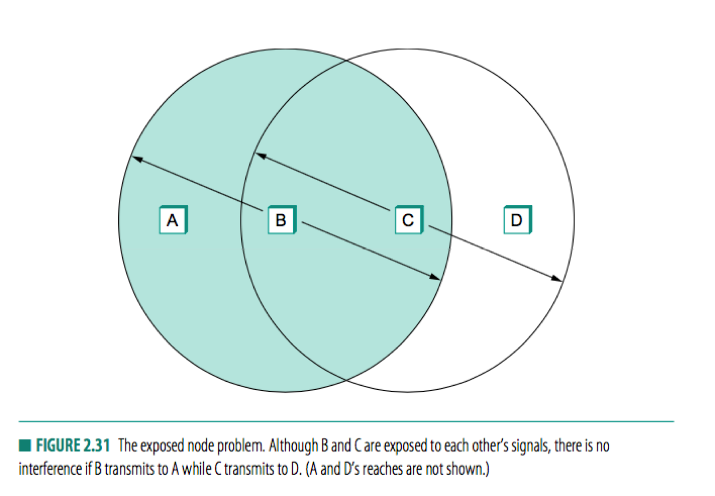

See diagram above. C can see B’s signals. When B is transmitting data to A, C will detect that the channel is busy, and will not send data to D, reducing efficiency.

Solution: Use RTS and CTS. Sender sends RTS, receiver responds using CTS.

Other nodes:

See CTS -- stay quiet

See RTS, no CTS -- okay to transmit

**2.** **Name the OSI layer or layers in which medium access control (MAC) is addressed and state whether MAC is** **typically handled in hardware, in software, or in both in the Internet architecture.**

Physical and data link layer, handled in both hardware and software

**3.** **Expain the effect of layering on end-to-end bandwidth.**

Effective data bandwidth.

More layers, more headers. Reducing end to end bandwidth.

Lowers the bandwidth, more layers to use.

(end-to-end bandwidth: how much data you can get from one end to another)

Reduces bandwidth because headers have to be added to each layer.

**4.** **Name the OSI layer or layers in which framing is addressed and state whether framing is typically handled in** **hardware, in software, or in both in the Internet architecture.**

Framing is in data link layer

data link layer is typically done in hardware, and could be done in software

**5.** **Show that the final parity check in a horizontal and vertical parity check code, if taken as the modulo 2 sum of all data bits, is equal to the modulo 2 sum of the horizontal parity checks and also equal to the modulo 2 sum of the vertical parity checks.**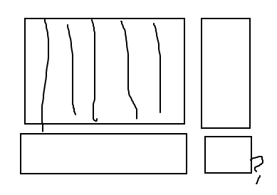

**6.** **Describe the benefits of error correction over error detection.**

**Error detection only detect the error, while error correction corrects the error**

**hhh**

**7.** **Give two arguments against IP reassembly in routers.**

**The goal of ip reassembly is to re assemble fragmented packets.  
(1) This should happen at the destination host.  
If it happens on the intermediate routers, then fragmentation will have to re-occur again and this is cpu intensive and time consuming, will result in delays. Hence this is done at the destination**

**(2) minimize fragmentation**

**8.** **List three components that contribute to end-to-end latency.**

**transmission delay, propagation delay, processing delay, queueing delay** 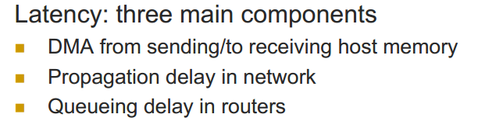

**9.** **The sequence number field in the TCP header is 32 bits long, which is big enough to cover over 4 billion bytes of data. Even if this many bytes were never transferred over a single connection, why might the sequence number still wrap around from 232 — 1 to 0?**

acking bytes not packets, start byte is random for 1) to prevent malicious attempts at guessing the start and 2) to account for leftover inflight packets

**10.**  **Explain the circumstances that give rise to the count-to-infinity problem.**

**A problem happens in Distance vector routering, when a link failure happens.**

**(Cancelled)11.**  **Assuming SWS=3, RWS=1, and independent timeouts per packet, construct a minimal timeline such that timeouts for packets in the send window are neither monotonically increasing nor monotonically decreasing.**

**???**

**12.**  **Name the OSI layer or layers in which error detection is addressed and state whether error detection is typically handled in hardware, in software, or in both in the Internet architecture.**

Error detection is in the data link layer, handled in hardware.

**13.**  **For TCP, why does the maximum packet lifetime, T, have to be large enough to ensure that not only the packet, but also its acknowledgements, have vanished?**

Have to make sure any new connection that is started does not think ACKs are for new packets

**14.**  **Caching is an important mechanism whereby frequently used information is replicated in order to provide fast access at different physical locations. Name three instances of caching discussed in the course that arise in the**

**context of standard Internet operation.**

**1.DNS: Cashing, Local DNS server often has the information cached**

**2. The learning bridges**

**3. soft state**

DNS, routing tables, NAT

**15.**  **At what OSI layer do Internet routers typically operate?**

Network layer.

**16.**  **Why are differentiated services approaches to supporting QoS considered more scalable than integrated services approaches?**

**Scalability through the use of only a small number of service classes n Two classes ¡ Regular and premium (i.e. first class and bulk mail) n Diffserv ¡ Proposes 6 bits of IP ToS field (26 = 64 classes)**

**17.**  **If SWS=RWS=5 in a sliding window protocol, if packet numbers do not wrap around, if packets do not arrive out of order, and if the next frame expected (NFE) is currently 17, why can't the receiver next receive a packet with sequence number 10?**

Invariant: LFA – NFE + 1 <= RWS. So LFA = 21.

The packet sequence number 10 is too low to be accepted.

**NFE-LFA <= RWS, pluggging in RWS = 5, NFE= 17, and LFA should >= 12, so sequence number 10 is outof the window size.**

**18.**  **Explain how a receiver detects the end of a frame with sentinel-based framing.**

**When reads a sentinel (in the frame), it detects the end of a frame.**

**19.**  **Why will UDP require a checksum with IPv6?**

It is mandatory as specified in RFC 2460, proposal for IPv6.

Because IPv6 removes the checksum.

**20.**  **Why might a host using an IEEE 802.11 access point (AP) continue scanning for other access points?**

**21.**  **Explain the meaning of the error, "address already in use," sometimes returned from calls to bind.**

In the case of TCP connections, it is because there is a TCP connection on that port and address is not in the FIN state, but the process is still trying to use that port/address combination.

In general, it could arise when trying to use a port which is already being used by another application.

**22.**  **Name the four components that uniquely specify a TCP connection and the length of each component in bits.**

**Source Port: 2 bytes**

**Destination Port: 2 bytes**

**source IP: 4 bytes**

**destination IP: 4bytes**

**23.**  **What does TCP use in addition to an estimate of RTT to calculate timeouts for adaptive retransmission?**

TCP estimates the variance of RTT in addition to the mean RTT.

**24.**  **Suppose a dynamic routing algorithm is employed to try to make routing tables correspond to least cost paths. What types of routing metrics are prone to producing load oscillations?**

**Queue size, Delay**

**25.**  **Explain in words (no equations) what the memoryless property of a random, exponentially distributed lifetime is.**

It usually refers to the cases when the distribution of a "waiting time" until a certain event does not depend on how much time has elapsed already.

**26.**  **What does UDP provide in addition to those services contained in IP?**

The **UDP port number** can differentiate between multiple services on the same host, using the same L3 identification. Using IP only it wouldn't be possible to host multiple services on the same station and easily differentiate between them.

**27.**  **What is the difference between congestion avoidance and congestion control?**

Control: minimize impact of congestion when it occurs

      Avoidance: avoid producing congestion

**28.**  **How does TCP guarantee that new connections do not receive segments from previous incarnations of the connection?**

**by using sequence number**

**29.**  **Describe the responsibilities of hosts and routers using DECbit to avoid congestion.**

DECbit is a special bit inside a packet that gets set to one when any router along the link experiences congestion.

Destination: echos the bit back to source

Source: check what percentage of packets were experiencing congestion.

-> Less than 50%: increase congestion window by 1 packet

-> More than 50%: reduce congestion window by factor of 0.875

Routers: Monitors queue length. Sets the DECbit when queue length > 1.

**30.**  **Give an argument why the leaky bucket algorithm should allow just one packet per tick, independent of how large the packet is.**

reduces per-packet overhead, use this approach when per-packet overhead is greater than the per-byte overhead

**31.**  **What is the purpose of the protocol field in the IPv4 header?**

To indicate what is the protocol of the data section, e.g. TCP, UDP.

**32.**  **List five services demanded by many applications but not provided by IP (nor typically provided by user-level code).**

**footage service, reliablity, congestion control, ordering,**

**33.**  **Explain the fundamental conflict between tolerating** **burstiness and controlling network congestion.**

**34.**  **Why does TCP begin by multiplicatively increasing its congestion window? What is "slow" about this approach?**

**35.**  **Having ARP table entries time out after 10-15 minutes is an attempt at a reasonable compromise. Describe the problems that can occur if the timeout value is too small or too large.**

**too small: congest**

**too large: could be wrong**

**36.**  **Give an example of scheduling discipline that is not work-conserving.**

**not: TDMA**

**is: statistical**

TDMA is not work conserving, fair queuing is work conserving (anything round-robin or FIFO based)

**37.**  **An approach to building special purpose hardware for massive high-speed switching fabrics is to use a Batcher sorting network followed by a self routing Banyan network. Why is the Batcher network included?**

**Batcher is there to sort**

**38.**  **How does IP limit messages to 64 kB in the common case? Why does IPv6 provide for longer messages?**

     IP has a maximum packet size of 65536 bytes which is limited by the “Total Length” packet field. IPv6 enables Jumbograms of up to 2^32 bytes. Bigger packets enable higher performance under high MTU conditions.

**39.**  **Why doesn't the adaptive time out mechanism of TCP update Estimated RTT in case an ACK is received for a segment that was retransmitted?**

**Only count for those transmit that got transmitted once**

**40.**  **If all the links in the Internet were to provide the reliable-delivery service, would the TCP reliable-delivery service be completely redundant? Why or why not?**

**NO, it would not be redundant. Because of its order reserve, control congestion.**

failure at routers, endpoints, example of the end-to-end argument

**41.**  **With Go-Back-N, is it possible for the sender to receive an ACK for a packet that falls outside of its current window?**

**Yes. Suppose the sender has a window size of 3 and sends packets 1,2,3 at t0. At t1(t1>t0) the receiver ACKS 1,2,3. At t2(t2>t1) the sender times out and resends 1,2,3. At t3(t3>t2) the receiver receives the duplicates and re-acknowledges 1,2,3. At t4 the sender receives the ACKs that the receiver sent at t1 and advances its window to 4,5,6. At t5 the sender receives the ACKs 1,2,3 the receiver sent at t2. These ACKs outside its window.**

**42.**  **Why does TCP use a 32-bit sequence number space instead of calculating a tighter bound based on RTT and link speed? Assume that complexity is minimal and that saving two bytes of header space {for example) is worthwhile.**

**Because RTT could be dynamic.**

**43.**  **Explain what “fair” means for flows traversing a router.**

Min-max fairness - no one uses more than requested, everyone gets the same service

**44.**  **Explain the relationship between physical distance and end-to-end latency in a TCP connection.**

**Physical distance partly contributes to end-to-end latency**

**45.**  **Under what circumstances does TCP Vegas increase its window size?**

**When Expected RTT – Actual RTT is smaller than alpha. Or when DEC bit is smaller than 50%**

**46.**  **Recall that with IP tunneling, we said that an IP datagram is carried inside of another IP datagram. How does the IP router at the end of the multicast tunnel know that the outer datagram contains an inner IP datagram (as opposed to simply being a normal IP datagram that should be forwarded along)?**

**Special header. just look at the protocal section**

**47.**  **TCP waits until it has received three duplicate ACK before performing a fast retransmit. Why do you think the TCP designers chose not to perform a fast retransmit after the first duplicate ACK for a segment is received?**

leaves time for packets delivered out of order, no specific reason for 3

**48.**  **What does a host do when it receives an ARP from an unknown host to a second unknown host?**

**Take note of the first unknown host, and ignore the second**

**I think the host will check if the first host is in its cache, if it is, then update the info. If not, just toss it away, because they don’t store useless information. (Lecture March 15th, at around 1:00:00)**

**49.**  **Why do internet routers stop at the IP layer rather than passing data up to TCP or UDP internally?**

Handling TCP or UDP is beyond the abstraction of Network Layer in OSI, which is what routers are operating at. There are many more protocols at the transport layer other than TCP or UDP and it is burdensome to handle all of them using the routers.

Maybe the network is heterogeneous, you have to use IP to deal with Ethernet, FDDI and everything

**50.**  **What traditional network class was under the most pressure before CIDR? Why?**

**Class B network. a company would first choose class B (class C has only 254 host spaces), but as the company grows big, the number of hosts it need to grow bigger, which gives a lot of pressure.**

**51.**  **Explain how fair queueing prevents flows from "saving up credit."**

**Enforce “use it or lose it policy”**

**Compute Smin = min(Si such that queue i is not empty**

**If queue j is empty, set Sj = Smin**

**52.**  **Suppose the throughput for a particular TCP connection is limited primarily due to the fact that one of the links it traverses is heavily congested. The congested link is shared by several TCP connections. How does the** **propagation delay for the TCP connection affect the throughput it receives?**

smaller latency results in higher throughput because send window increases on flows with lower latency, higher latency is penalized due to the congestion

**53.**  **In RED gateways, explain why MaxThreshold is actually less than the actual size of the available buffer pool.**

**Because we drop 100% when AvgLen is larger than MaxTh, so Max needs to be a bit less so that AvgLen could actually exceed**

**54.**  **Suppose packets on a wireless link consist of N data bits and H header bits each, where H is fixed. Suppose bits are received in error with probability P, independently of each other, and that N is adjusted to maximize the throughput of data in bits per second. If P gets larger, does the optimal value of N get larger or smaller? Why?**

**Gets smaller. The larger packet is, the higher P of whole packet**

**55.**  **Data link protocols almost always put the CRC in a trailer, rather than in a header. Why?**

**So the receiver can read useful information first as it is doing long division, and then compare. Efficient**

**56.**  **What is the maximum bandwidth attainable on a TCP connection with RTT=100 milliseconds? Explain how TCP options can be used to raise this limit.**

**We can increase window size to get more bandwidth**

max window size = 64 KB by default, options can be set to raise that

**57.**  **As we have seen many times in class, a sliding window abstraction can be used to bound transmission rates. Why would anyone propose a rate-based mechanism, given that buffer (window) space is intrinsically available** **from the end hosts?**

rate-based gives smoother use as opposed to window-based which is burstier because rate-based gives far cleaner specification of the time when packets are sent

**58.**  **Why is an ARP query sent within a broadcast frame? Why is an ARP response sent within a frame with a specific destination LAN address?**

**Broadcast so others know how to get to you. Specific because only destination needs to know the query response.**

**59.**  **List the contents and explain the purpose of each segment transmitted when a TCP connection closes in a typical way.**

**Fin and then FIn-Ack**

FIN J - Client tells server application is finished

ACK J + 1 - Server acknowledges FIN message

FIN K - Server tells client application is finished

FIN K + 1 - Client acknowledges FIN message

**60.**  **Give two good reasons to allow branching – that is, the ability to support multiple protocols above and below any given protocol-in protocol graphs.**

**Different services (TCP UDP) different tech (lower layer)**

**Branch above to allow multiple protocols**

**Branch below to be able to use multiple technology**

**61.**  **Intuitively, what is the goal of TCP Vegas? Why is this goal desirable?**

**Congestion control and avoidance lol**

**62.**  **Name an advantage of switched media over shared media. Name a disadvantage.**

**advantege-no collision**

**disadvantage-switch delays**

**63.**  **How does CIDR solve the problems of inefficient address allocation and limited number of networks associated with the traditional class model?**

**Use Mask**

**64.**  **How does fast retransmission improve TCP's overall utilization of network resources?**

**Does not wait for timeout to retransmit**

**It decreases the idle time by triggering retransmission with dup ack.**

**65.**  **Compare the problem solved by Nagle's algorithm to silly window syndrome and describe the similarities between the two problems.**

**It all deal with data in tiny pieces**

Nagle’s algorithm deals with applications that send small pieces of data (TCP lecture slide 52) (problem at the sender), silly window syndrome - TCP only acknowledges half a MSS at a time (problem at the receiver)

**66.**  **IP hosts that are not designated routers are required to drop packet misaddressed to them, even if they would otherwise be able to forward them correctly. In the absence of this requirement, what would happen if a packet addressed to IP address A were inadvertently broadcast at the link layer?**

**Duplicates may happen.** designated receiver would receive too many copies of the same packet

**67.**  **Assuming that all routers and hosts are working properly and that all software in both is free of all errors, is there any chance, however small, that a packet will be delivered to the wrong destination?**

**Yes.** DHCP assigns IP address to one machine, then that address is assigned to another machine

**68.**  **The original Internet mechanism for looking up names used central hosts.txt table, which was distributed to all hosts every few days. Describe two reasons why this mechanism is no longer used.**

**Too large and inefficient.** scalability, SPOF

**69.**  **Describe two advantages of using encapsulation (tunneling) for distributed internet applications such as virtual private networking.**

1. **you can hide what’s going on inside the tunnel (whether its VPN)(hide functionality of the second layer)**
2. **only need to change relevant routers (internet ppt page 65)**

**70.**  **A friend comes to you and asserts that network programming is too hard; complaining that after select indicates data available on a connection, read returns no data. Explain your friend's problem.**

**Not addressed to him**

**71.**  **How does a RED gateway act to avoid congestion?**

**Look at AvgLen of buffer back log, and considers min and max threshold.**

**72.**  **Under what circumstances may coarse-grained timeouts still occur in TCP even when the fast retransmit mechanism is being used?**

**When bulk of packets is lost.** The last packet in a window or burst gets dropped

**73.**  **List the contents and explain the purpose of each segment transmitted during a TCP connection setup.**

**74.**  **Due to the use of CIDR, it is possible that the destination address on an incoming packet will match several entries in a routing table. In such a case, which routing entry or entries will be used for forwarding the packet?**

**Longest match**

**75.**  **A class B network on the Internet has a subnet mask of 255.255.240.0. What is the maximum number of hosts per subnet?**

**240 = 1111 0000, 12 zeros, 2^12 -2 = 4094 spaces**

**76.**  **Most IP datagram reassembly algorithms have a timer to avoid having a lost fragment tie up reassembly buffers forever. Suppose a datagram is fragmented into four fragments. The first three fragments arrive, but the last one is delayed. Eventually the timer goes off and the three fragments in the receiver's memory are discarded. A little later, the last fragment stumbles in. What should be done with it?**

**waiting for its other parts to come, it other parts doesn’t come before timeout, it will be discarded too.**

**77.**  **Give a potential disadvantage when Nagle's algorithm is used on a badly congested network.**

**it will slow down what what you are sending.** If a packet is lost, new packets will never be sent until the buffer is full

**78.**  **Explain Karn's algorithm. Why do we need it?**

**For each retransmission, double RTT, and then congestion exponential back off.**

Karn’s algorithm excludes retransmitted packets from the RTT estimate, this is needed to not overestimate the RTT.

**79.**  **How can ARP be used to redirect traffic for a given host? Give pros and cons of such a technique.**

**80.**  **Explain the hidden terminal problem and how it is solved.**

hidden terminal problem occurs when a node is visible from a wireless access point (AP), but not from other nodes communicating with that AP.

Increasing Transmitting Power From the Nodes

**81.**  **Give the major reason why TCP does not behave well in wireless environments.**

TCP assumes congestion if packets are dropped, but packets can be dropped for other reasons in wireless environments

**82.**  **In queueing theory, explain why the arrival rate,l , must be less than the service rate, μ.**

**Otherwise can’t process fast enough and arrival will back up**

**83.**  **Name and describe the type of multiplexing traditionally employed in data networks.**

**Time division? Statistical division?**

**84.**  **In the Perlman distributed spanning tree algorithm, why does the root bridge periodically send messages even after the tree is determined?**

**Because node or links can go down, so update is always needed.**

**85.**  **What is the difference between a cumulative and a selective acknowledgement?**

**cumulative ACK: only sends an ACK for sequence s.t all packets before it has been received**

**Selective: sends ACK with seq num that is just received**

**86.**  **In a sliding window protocol, explain why would you ever use an RWS that is not equal to the SWS.**

never makes sense for RWS to be greater than SWS, RWS represents how many out of order packets receiver wants to buffer

**never use RWS that is larger than SWS**

**RWS could be smaller than SWS when my network is not in good shape, I never really fill the RWS. small RWS allocate less resources on the receiver side.**

**87.**  **Why does Ethernet used fixed time slots during backoff? What could go wrong if the fixed slots were not used?**

So a full transmission can be completed during the backoff period. There would be more collisions otherwise.

**88.**  **Cell switching methods essentially always use virtual circuit routing rather than datagram routing. Give a specific argument why this is so.**

**89.**  **Define the process of routing.**

**Routing is the process of selecting a path for traffic in a** [**network**](https://en.wikipedia.org/wiki/Network_theory)**, or between or across multiple networks.**

**90.**  **Describe the problem solved by sliding window based ARQ protocols.**

**Packet out of order, link does not achieve full bandwidth**

**91.**  **Describe the problem solved by reliable transmission.**

**92.**  **Describe two ways in which the topology of the Internet has evolved over the last ten years.**

Initially a tree, now multiple backbones

**93.**  **Draw a protocol graph for the Internet, including at least the following: Wi-Fi, Ethernet, Bluetooth, FTP, HTTP, IP, TCP, SSH, and UDP.**

**94.**  **Explain the main bottleneck for sending short and long messages.**

**Short: propagation delay**

**Long: Transmission delay**

**95.**  **Explain the main drawback of the stop-and-wait ARQ algorithm.**

**Too slow: does not utilize full bandwidth**

**96.**  **Why does Ethernet use binary exponential backoff during contention resolution?**

**Each time probabiliy of collision drops.** Avoid repeated collisions

**(cancelled)97.**  **Why does reverse path broadcast assign parent routers to each LAN?**

**FUck no**

**98.**  **Why does TCP use a 32-bit sequence number space instead of calculating a tighter bound based on RTT and link speed? Assume that complexity is minimal and that saving two bytes of header space {for example) is worthwhile.**

**Dynamic RTT, there is not tight bound**

**99.**  **With the selective repeat protocol, is it possible for the sender to receive an ACK for a packet that falls outside of its current window?**

**Fake timeout.** Yes, when the first packet of the window is dropped

**100. What is the role of the NAV in IEEE 802.11?**

**Tell node how long you should keep quiet.**

NAV (Network Allocation Vector) is updated based on overheard RTS/CTS/DATA/ACK packets and tells stations listening how long the medium will be busy for. Virtual Carrier Sense

**101.How do sniffers work? Will they work on all networks?**

**Monitor; No, only on shared medium**

**102.Describe the pros and cons of using MTU discovery on a path prior to data transmission.**

**pros: avoid IP fragmentation as much as possible**

**cons: takes time**

**103.How can NAT be used to load balance a company’s servers?**

**Balances load on the servers by assigning addresses in a round-robin fashion**

The NAT gateway can round robin internal servers

**104.What is the role of the root servers in DNS?**

**Contacted by local name server that can not resolve name**

**Contacts authoritative name server if mapping not known**

**Gets mapping and returns it to local name server**

Authoritatively delegate top-level domains

**105.How can an attacker poison a DNS cache and what is the impact?**

**An attacker could insert wrong mapping or spoof mapping in a DNS server, so the client may get a wrong IP**

Attacker can fake a DNS response and other users will be given this fake DNS response

**106.What is the role of a BGP border router?**

**Connects AS to Internet**

**Provide route to external internet**

To share and update global routes

**107.Why does BGP use path-vector routing?**

**Quick loop detection**

**Quick convergence**

**No count-to-infinity**

Cannot use link state routing because it would expose internal structure, cannot use DV because it converges too slowly and there are loops

**108.Why is it ineffective to use and ACK for broadcast and multicast communication in wireless networks?**

**ACK not unique**

**109.Why does a node in 802.11 suspend is collision counter when the medium is busy?**

**if every node continues to count when a medium is busy, at the next available time, everybody will send again because they all finished counting. That cause clide again.**

Message is being transmitted, wait for message to be delivered

**110.Given an example of when the use of 802.11 can lead to unfairness?**

**RTS could be collide, it’s possible that one node back off much more than other node.**

Occurs when one node has backed off much more than some other node

**111.Why is buffering needed in switches?**

Sufficient network buffers prevent the excessive delay caused by lower-level protocols working out what traffic was dropped.

Output port buffering needed to queue packets until output port available to send

Input port buffering needed to temporarily hold received packets until they can be processed

**112.Why are metrics like link utilization and delay difficult to use effectively in routing?**

**It leads to load oscillation**

**113.What is the effect of setting “infinity” to 16 in distance vector routing?**

**Link cost of more than 16 will be considered unreachable, and counting to infinity will finish after reaching 16.**

**114.What is the impact of using different interframe spacing in IEEE 802.11?**

**Creates different priority levels for different types of traffic!**

**115.Why can’t we really represent a wireless “link” as a node with a circular radius?**

**There are obstacles and transmission medium ma not be uniform.**

There’s too much interference for the link to be able to only receive in a circular radius.

**116.To provide more reliability than a single parity bit can give, an error detecting coding scheme uses one parity bit for checking all the odd numbered bits and a second parity bit for all the even numbered bits. What is the hamming distance of this code?**

**2**

1 to append the second parity bit and 1 to flip the first parity bit.

**117.Explain the difference between flow control and congestion control.**

flow: preventing one sender from overtunning the capacity of a slow receiver

congestion: preventing a set of senders from overloading the networking

**118.How is self-clocking used in TCP?**

* reception of ack triggers next packet transmission
* adapts to bottleneck bandwidth

**119.What protocol was the** **precursor for both the Ethernet and Wi-Fi MAC protocols?**

ALOHAnet